**M3 - Evaluate the performance of a computer system**

**Introduction**

In this report, I will be explaining how I installed ‘Novabench’ and I am going to review the results that I got for it. I tested the performance of a computer system on a laptop. I have screenshots to prove that I reviewed the system.

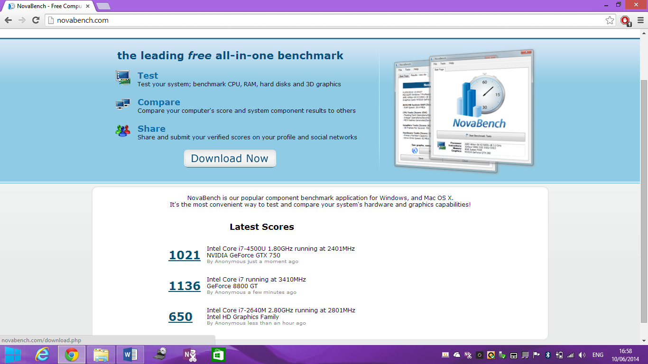

The first thing I did was go on the website to download ‘NovaBench’. They were choses and I had to choose which operating system I was using. I followed each of the steps and these are the screenshots alongside it.

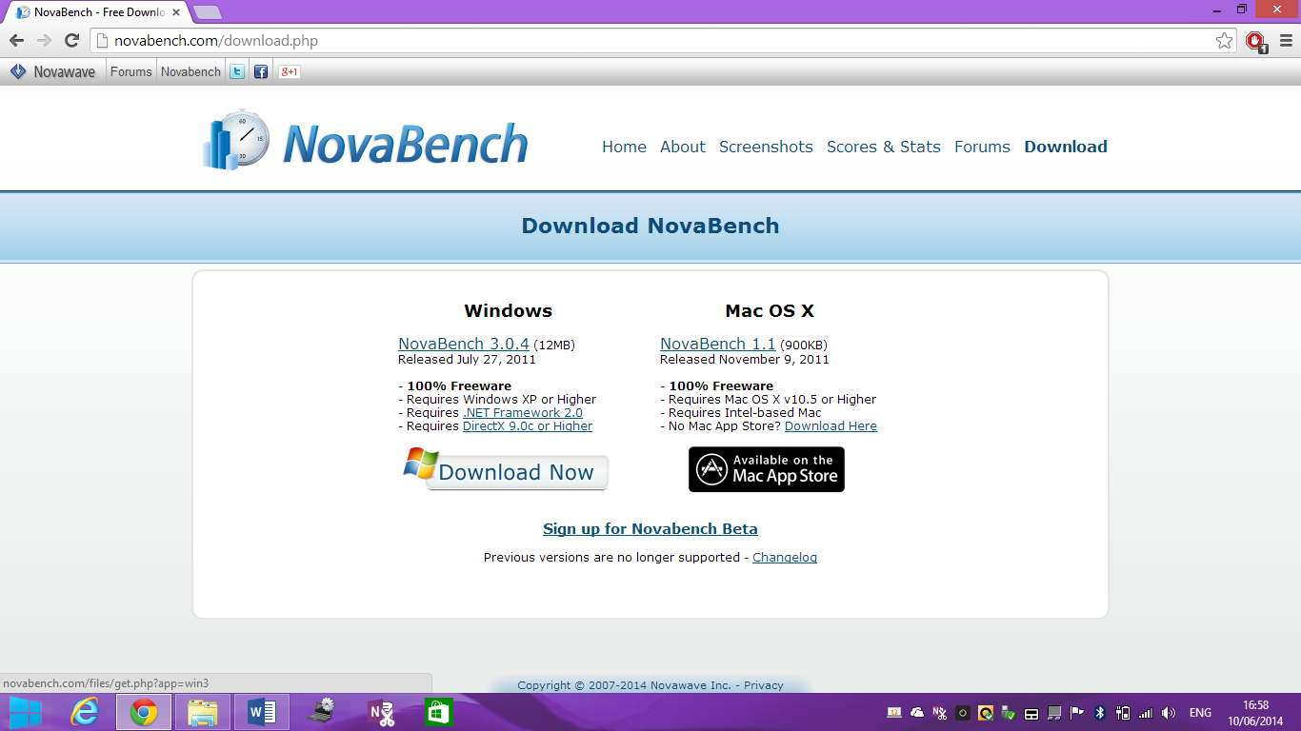

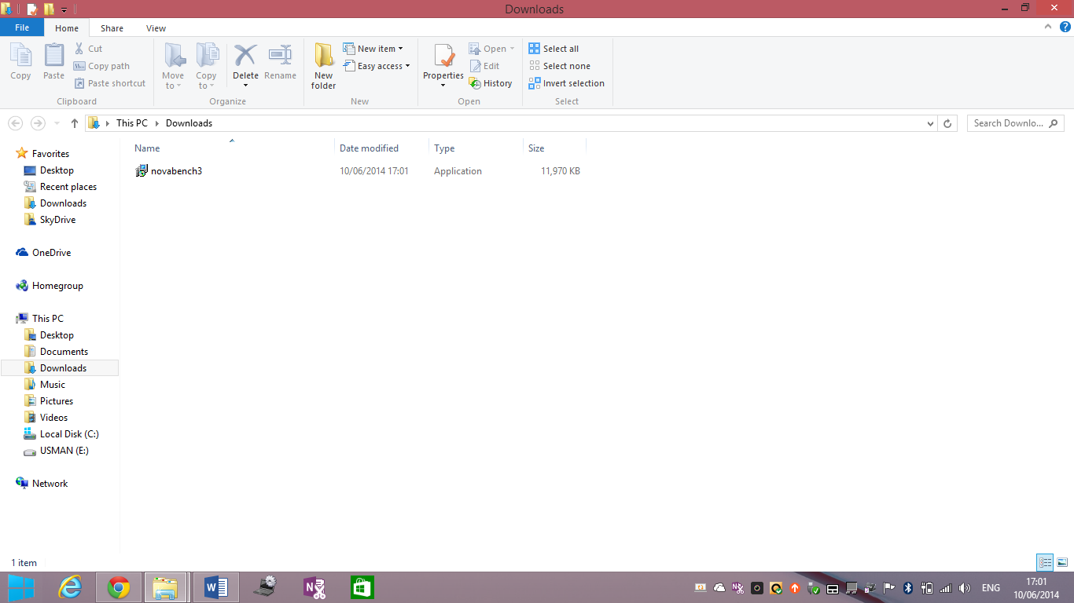

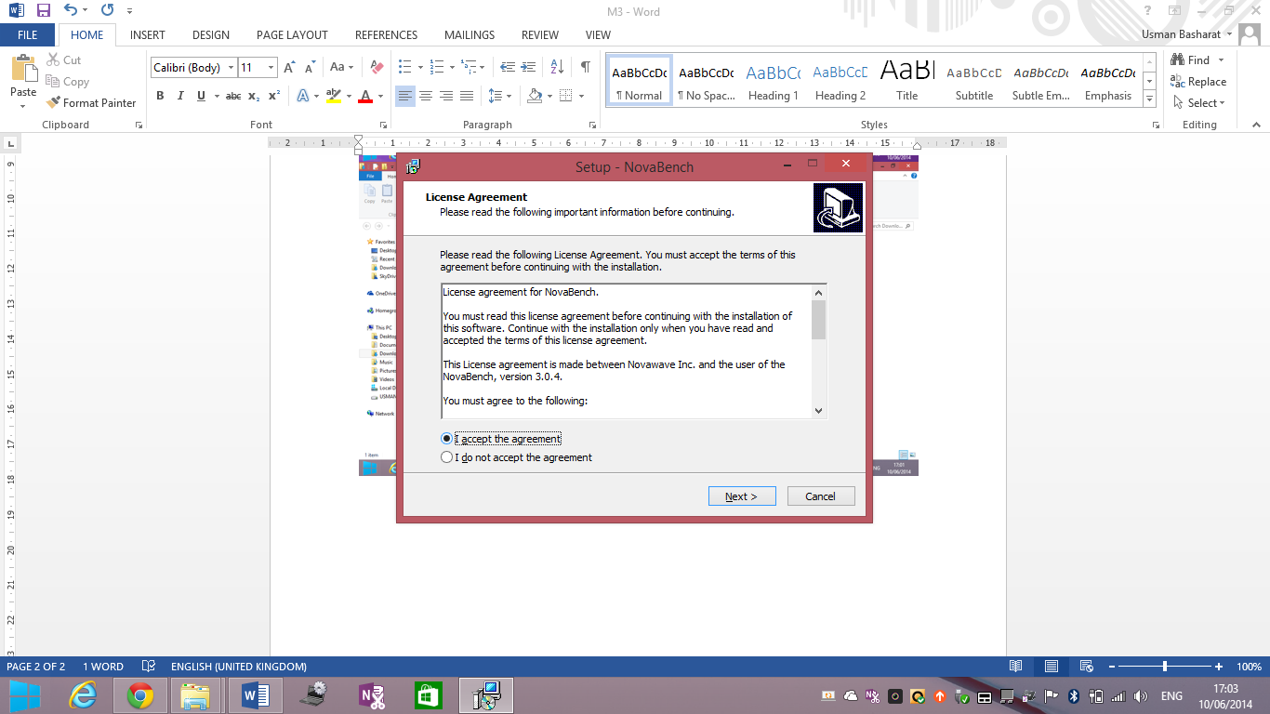

As any software to install, the user needs to accept the licence agreement. I read through these licence and accepted the terms to move on.

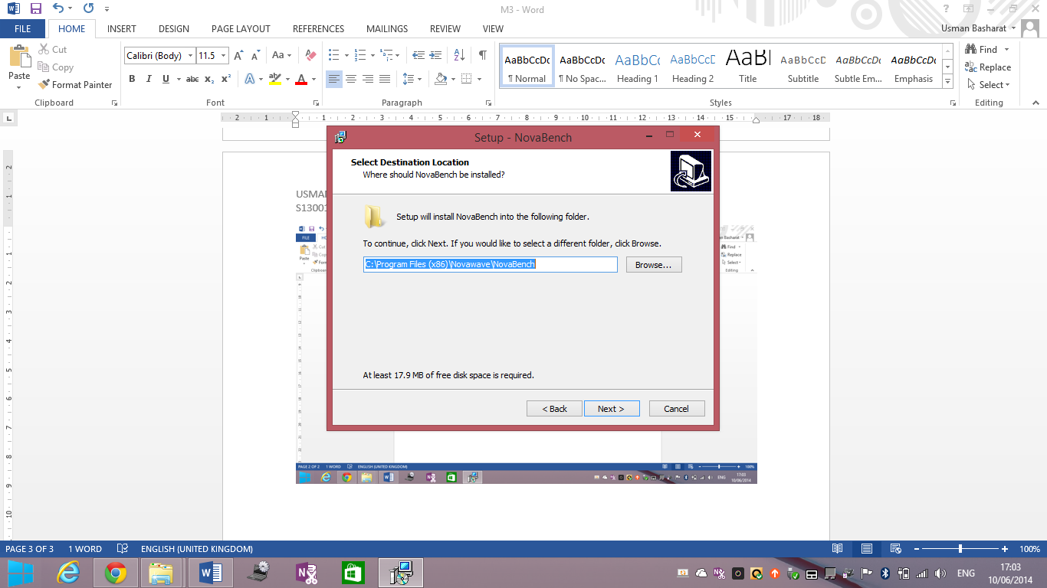

This is the next step where the program is located. If you want to change the location, you can browse and change it to where it suits you. However, I did not change it and I moved on.

This is the shortcut of the program. You can change the name of it but as before, I moved on.

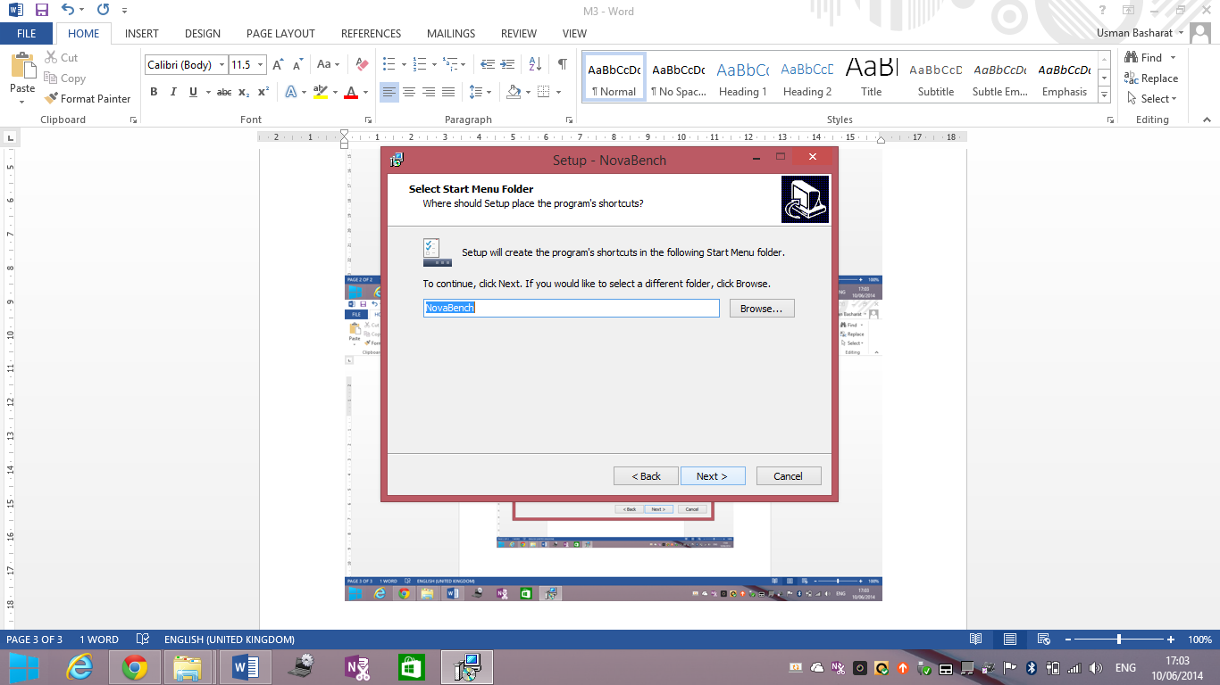

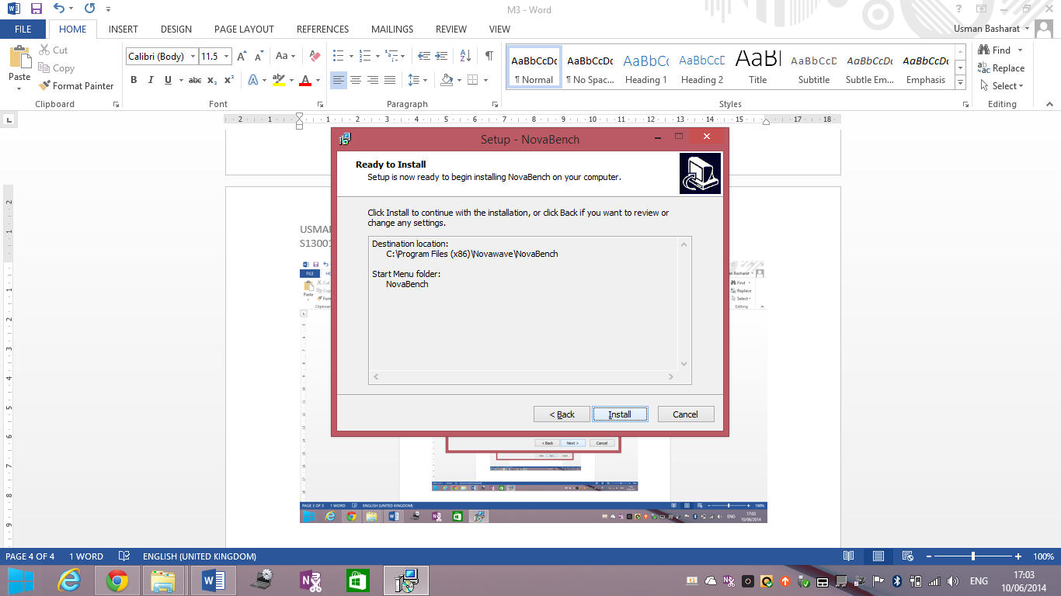

This is the ‘overall’ of it. If something is wrong, you can go back, but click install and it installs the program for you. Once it is done installing, you can test the program and launch NovaBench.

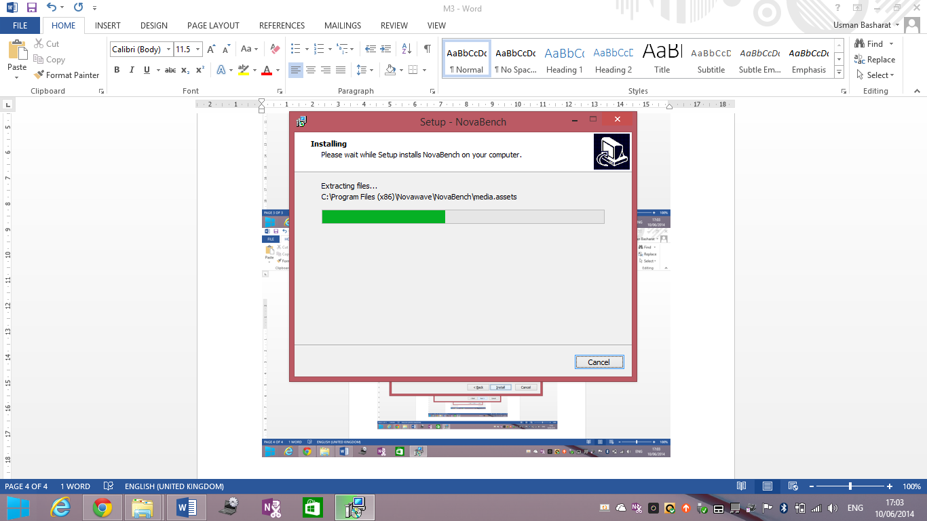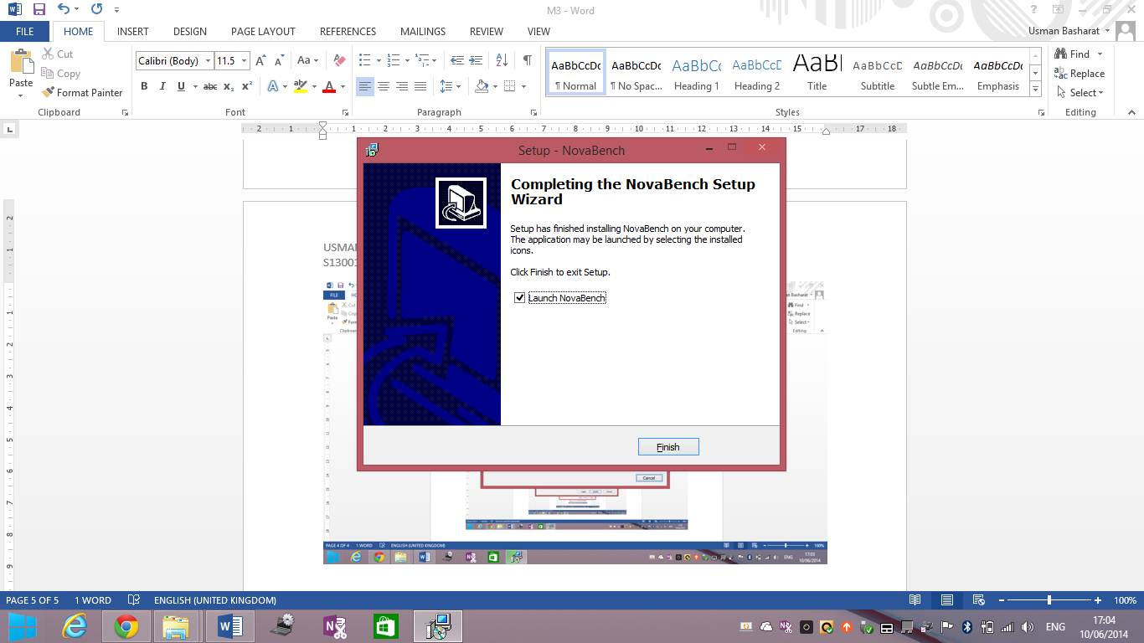

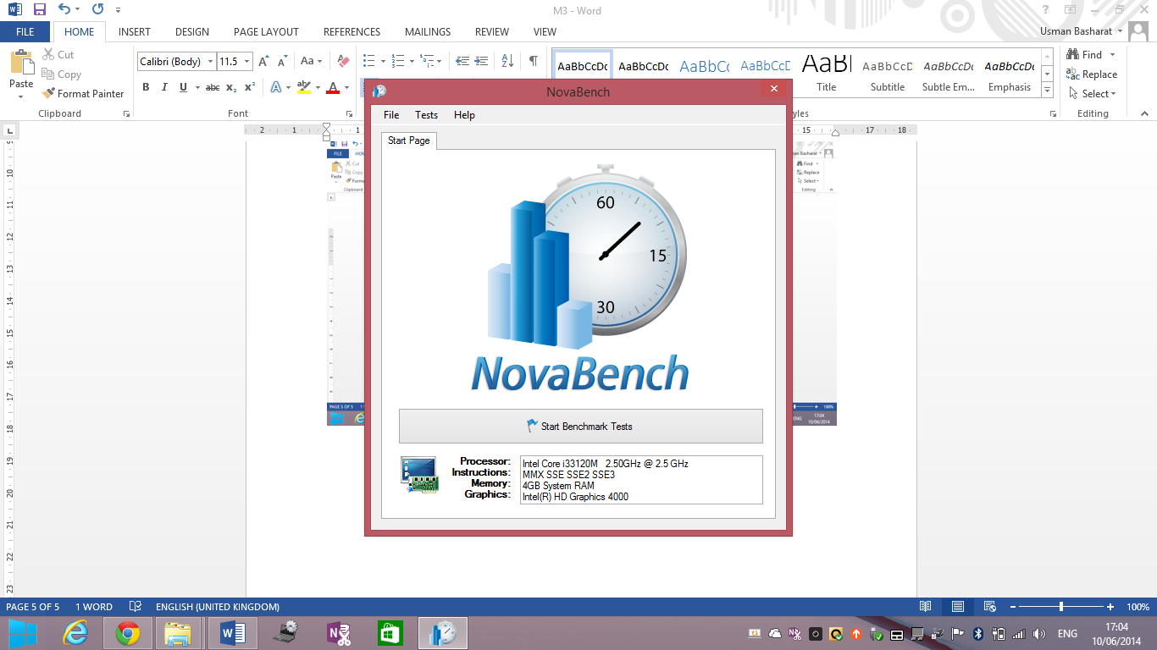This is the important part of this whole assignment. As you see this screen, you know that you are on the right part. I want to test it and it takes time to test. Once it is complete, you will get a result.

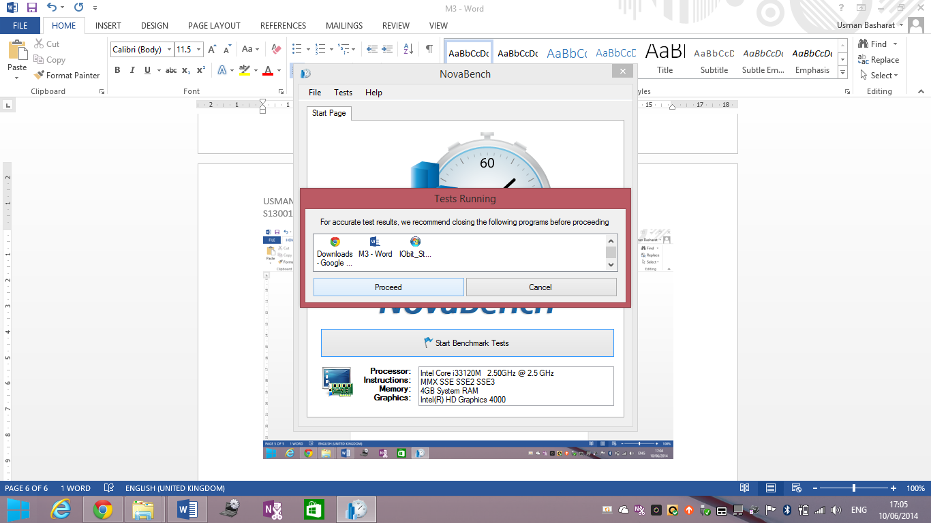

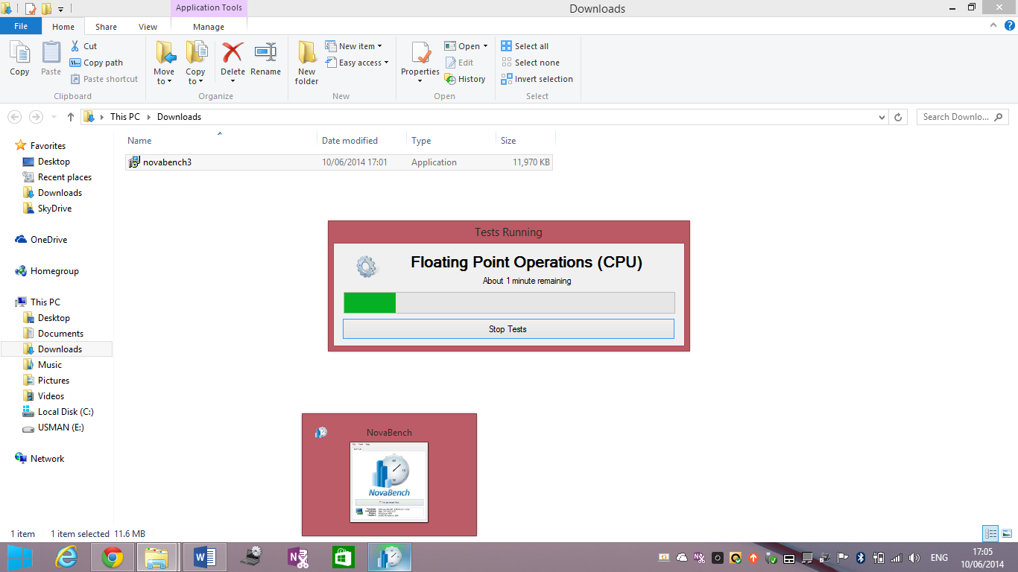

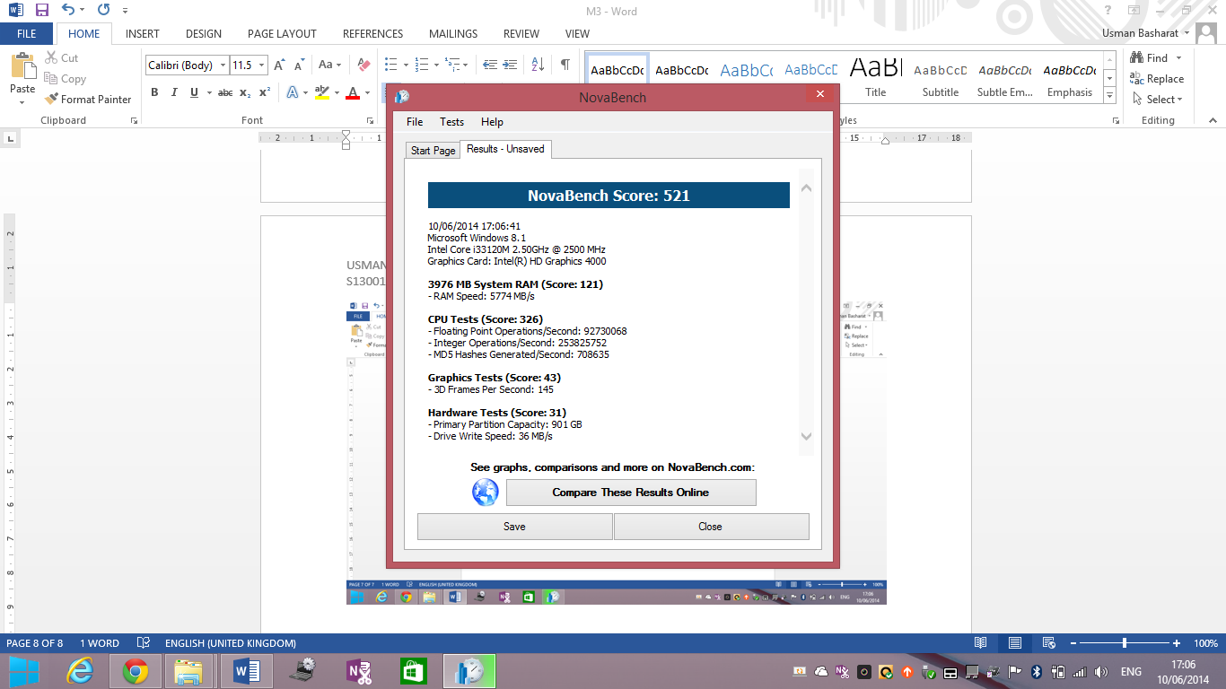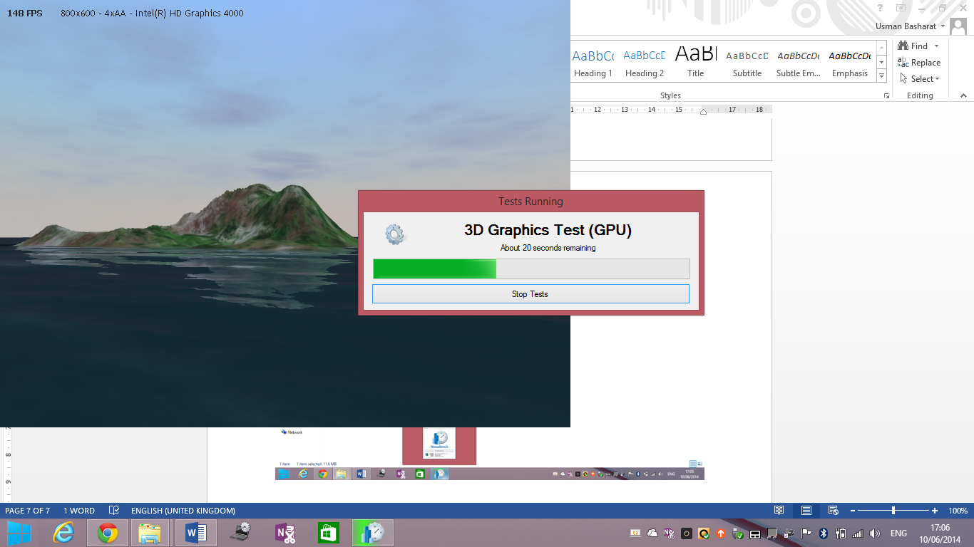

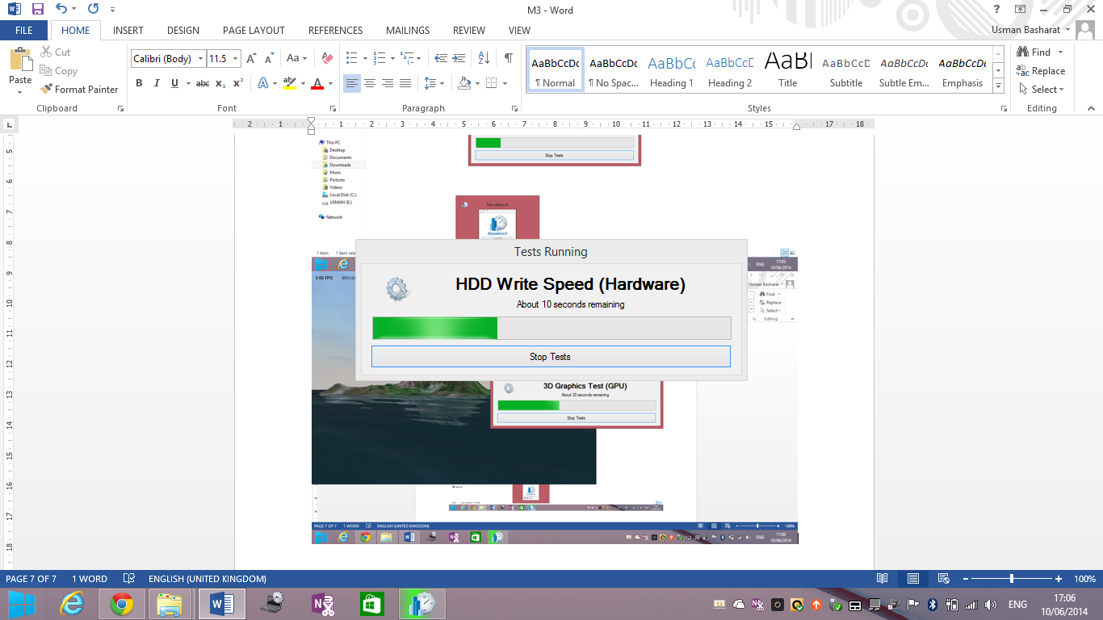

It takes time, but the end result and I am going to review it.

**REVIEWING THE RESULTS**

These are the results as you can see. They are broken down into separate scores for the RAM, CPU, Graphics and Hardware tests. The overall score of this is 521 and comparing them to other results, it is good taking into a fact that it is not a computer, but a laptop. The highest score for this Nova Bench goes up to 3000. This is high as it evaluates the overall performance and features of the system. For the 3000 score, it has the processor of Intel Core i7 which is the highest and it is pretty fast. As you can see, mine is i3 which is a big difference. It has these features and it is good for the score that they have given. Intel Core 1.3 is used on this system with Windows 8. This is good as the other scores contain other GPU and processers with it such as AMD and a lower GPU e.g. 3000.

**RAM**

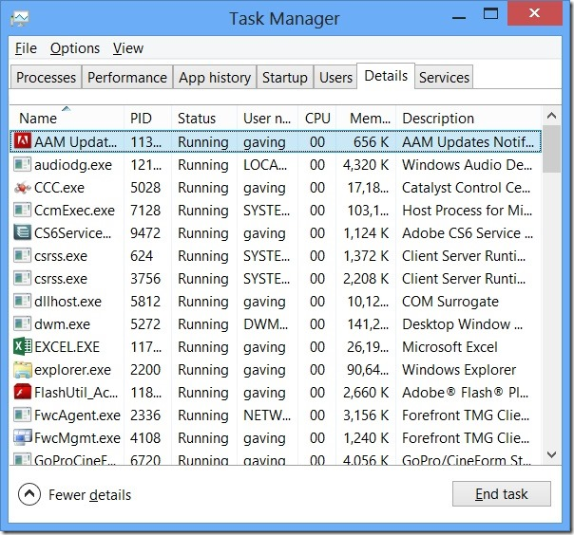For RAM, it says it is 397MB that is 4GB. The overall score is 121 and the speed of the RAM is 5774 MB/s. It is important for any computer to have a high Random Access Memory to benefit of opening up more than one program and multi-tasking to complete more than one tasks. This prevents the computer from freezing. When I open and close the system, it takes less than 3 minutes to do both. This is because of the RAM and of how high it is. They are higher RAMs for this unit. However, I chose this RAM as I only complete my work for it. In addition, I do not need any higher RAM as it is not necessary. I feel that this RAM is complete for the laptop. If any user wants a faster computer, they would need to upgrade the RAM.

This is the task manager and it shows the ‘multitasking within the computer. These are all the apps that are running at once and the user and end them if the program is slow and has crashed. The user can check out all the details on this.

**Graphics**

Graphics for this system is low and the overall score is 43. This is because this graphics test is not necessary for the use of my laptop. Graphics is only gets a high score if the graphics card is the latest. The latest is the most expensive and these are used mainly for gaming. People need high graphics in order to make a game with the RAM being high so they need to save it on the unit. The graphics card is card that is inserted on the motherboard where it helps to process the design. The better the graphics card, the better the graphics. Graphics card does not come in cheap to replace. The better the graphics card, the higher the price. Some types of Graphics card is AMD and NVidia.

**CPU**

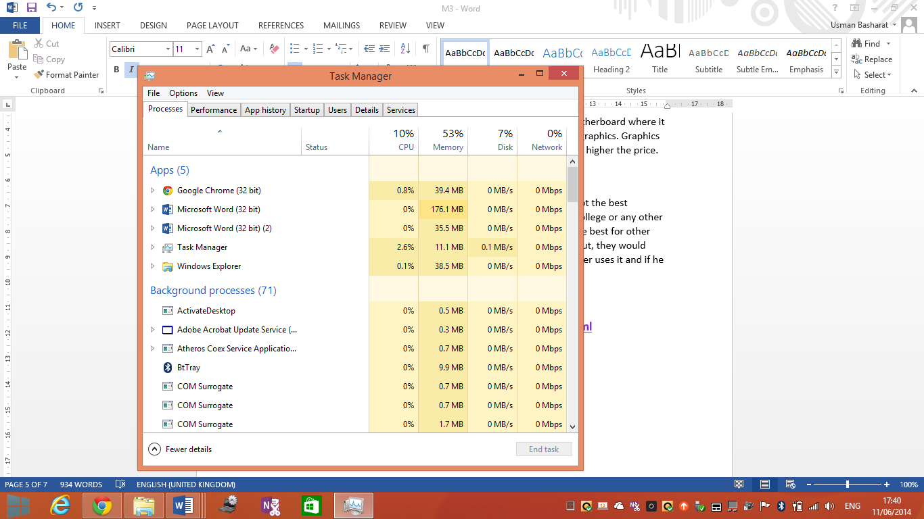The central processing unit (CPU) for this unit is Intel i3. Obviously, it is not the best processor, but I find it satisfying because I only use my laptop to do my college or any other work that needs to become complete. They are higher processors that are best for other uses such as if someone in a business has a lot of work to do day in and out, they would need to an higher one e.g. Intel i5 or Intel i7. It all depends on how the user uses it and if he uses it often. The picture shows how the CPU the CPU is running on ‘Task Manager’.

**Hardware**

Hardware is the one where I needed most. The score is 31, but the capacity of it is 901GB. This is very high and it can save loads of work on this computer. This is the one I needed and I have done so. The benefit of having a high capacity of hardware is that any user using it can store documents, files, images, videos and it is a lot to save on. Of course, if any person has saved a lot of work, it could run out, but this is a lot of capacity and the benefit is that it will take a lot of time to fill up.